Reading Revolution: Thematic Literature in Spanish and English All Day Long!

All content of presentation is on Pinterest: http://www.pinterest.com/drmstewart/
Each theme is under its own board.
PPT available at maryamandastewart.com
@drmandystewart
Mstewart7@twu.edu
Resources:
The Learning Patio ($1.99/month for some resources, others are free)
- English/Spanish foldable books, biographies, five senses
www.thelearningpatio.com
Colorín Colorado
- Book lists divided by theme in English and Spanish
www.colorincolorado.org/read/forkids/
Primera Escuela/First School
- Printables of ocean animals with and without letters for tracing
- Thematic craft ideas, internet links, and books
www.primeraescuela.com/themesp/animales/oceano.htm
Discovery Kids en Español
- Ocean life information and games
http://www.tudiscoverykids.com
Spanish Playground @SpanishPlaygrd
- Videos, printables, and Spanish language teaching resources for young children compiled from many sites
www.spanishplayground.net/

El Béisbol/Baseball

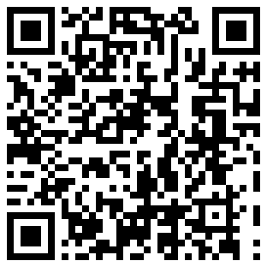

El Mundo Marino/Ocean Life

Los Líderes/Leaders

